**A linear Model of Home Loan Prophecy**

**Group Id: SM2020CSE47507**

**Rayhan Ahmed 2016-1-60-141**

**Naeem Ul Hasan Chowdhury 2017-2-60-065**

**MD. Sharif Mulla Mahin 2017-2-60-023**

**Project information:** Every finance bank deal with various types of loans. But in this project, we just concern about home loan of the bank. They have presence across all urban, semi urban and rural areas. Bank wants to automate the loan eligibility process based on customer detail provided while filling online application form. These details are Gender, Marital Status, Education, Number of Dependents, Income, Loan Amount, Credit History and others. The detailed analysis is carried out on given data set (615 observations). To automate this process, those are eligible for home loan amount so that they can specially target these customers.

Our plan is checking the customer eligibility for getting home loan.

Here is the dataset:

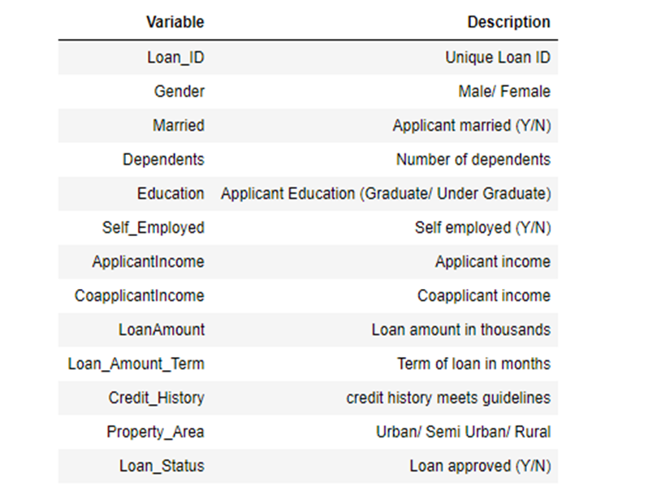

This is a standard supervised classification task. A classification problem here we have to predict whether a loan would be approved or not.

We are using random forest, KNN, SVM algorithm.

Input Customer Details

D

Algorithm

Test Set

Model

Training Set

Data Pre-processing